Sign-Up Instructions for Families: Step-By-Step

Welcome, Pasadena Educational Foundation families - Pasadena Educational Foundation has partnered with codeSpark, the #1 learn-to-code app for children ages 6-10, to provide your child access to use the program at home! The platform’s word-free interface and highly engaging gameplay teaches critical thinking, creativity and collaborative learning through a STEM based curriculum. Please follow these instructions to create your account for at-home use!

Here is the code for your free year-long codeSpark membership:

CSZF-ECP1-ERQX

Creating Your Account
- Go to https://accounts.codeSpark.com/promo and enter the code above. Then click “Redeem Code”. | 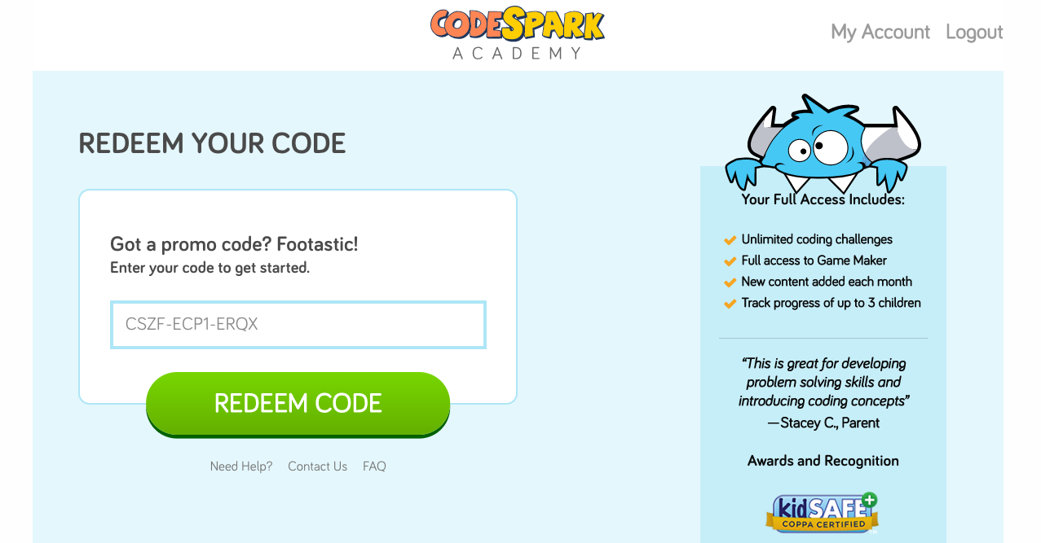
- Enter your email address on the popup that displays. | 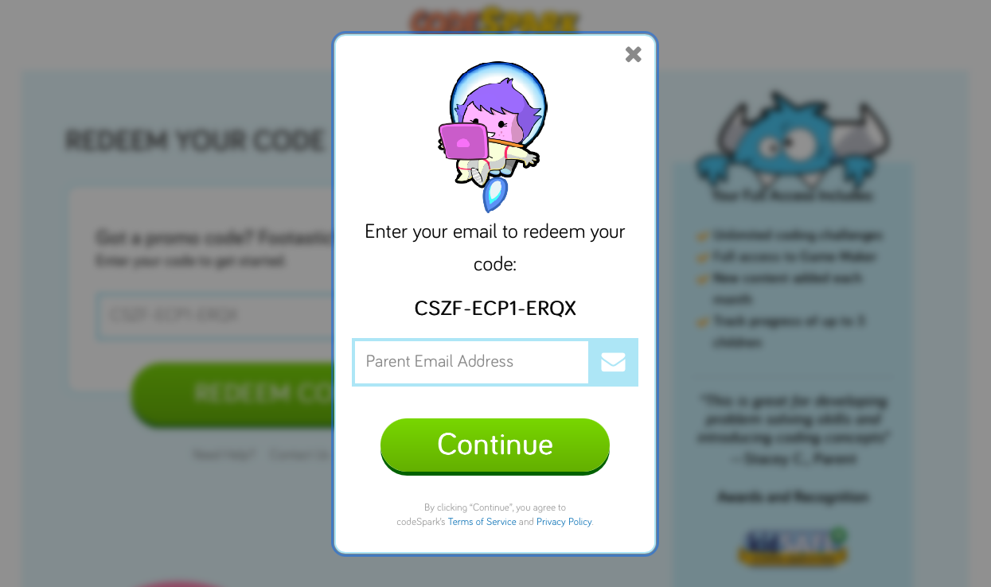
- If you have an account, you will be prompted to login. If you do not have an account, you will be prompted to register.  - Log in or register for an account by entering your information into the open fields. | 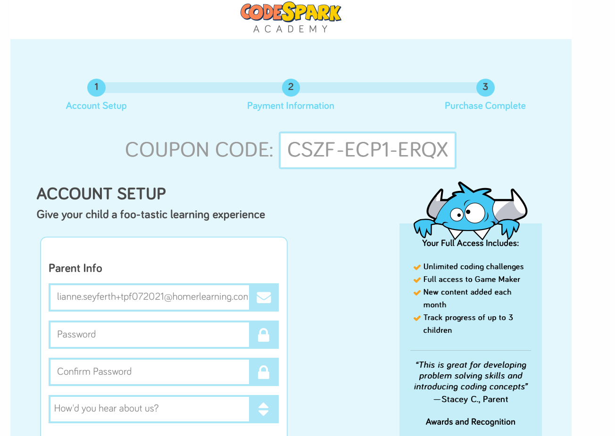  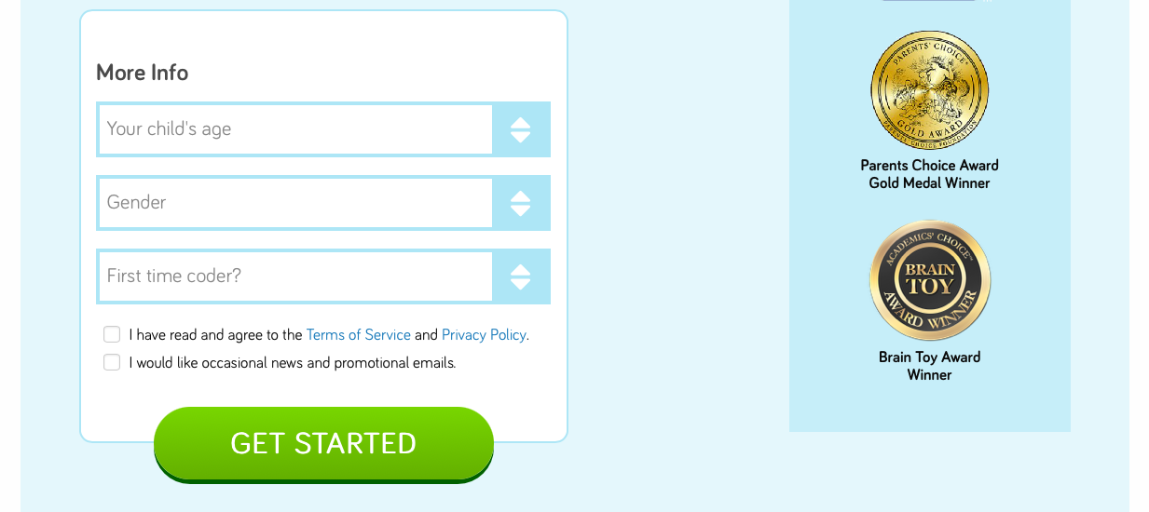
- On the next page, fill out your name and click “Accept Your Offer”. | 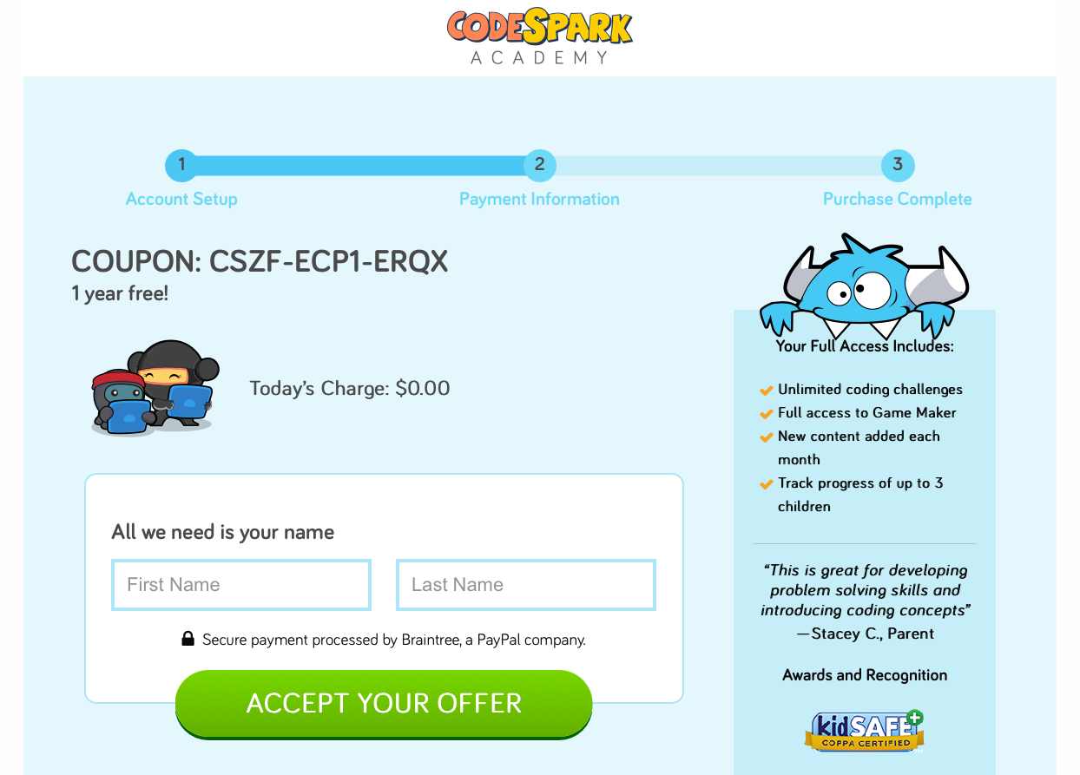
- Once you have applied the promo to your account, all you need to do is log in with your email and password in the app or at https://codespark.com/play/ on your computer to unlock your account. | 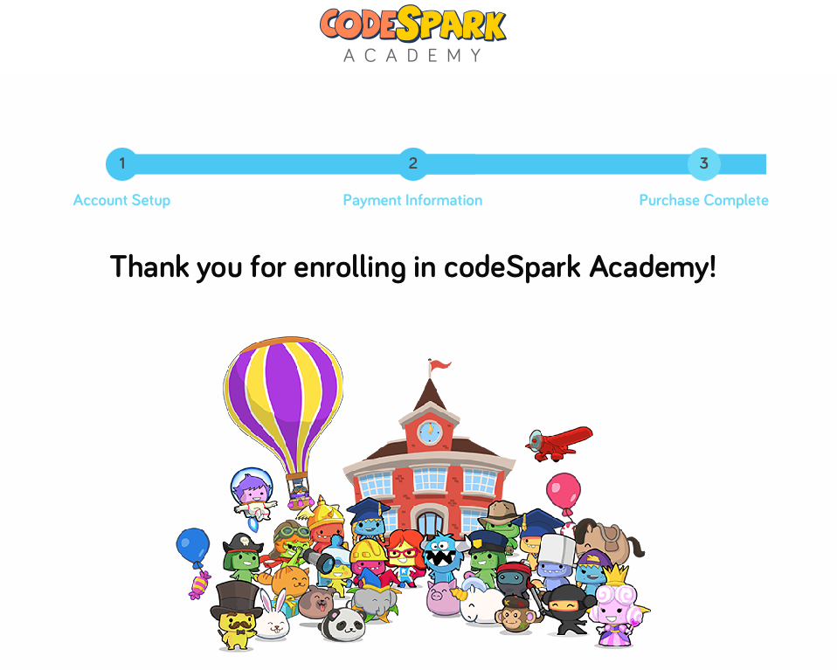
Downloading Onto Your Device
After creating your account on our site, you can access codeSpark on your computer at https://codespark.com/play/ or download the app on your device from any of the following app stores:
- For iPads and iPhones on the Apple Appstore
- For Android Devices on the Google Play Store
- For Fire Tablets on the Amazon App Store

About codeSpark
Co-founded by digital entrepreneur Grant Hosford and Disney veteran Joe Shochet, codeSpark’s intuitive, word-free interface and patented technology lets kids learn to code before they even know how to read. codeSpark Academy is available for home use or via public schools, libraries, and nonprofits and has a presence in more than 1/3 of the school districts in the United States. codeSpark Academy has been honored with multiple, top-tier awards in both the academic and technology sectors, including a Parents’ Choice Award, and continues to educate and entertain over 30 million children and counting.

